SQL Queries for stock.db

1. Table name – “basic_stock_data”. Print Schema

sqlite3> PRAGMA table_info(basic_stock_data);

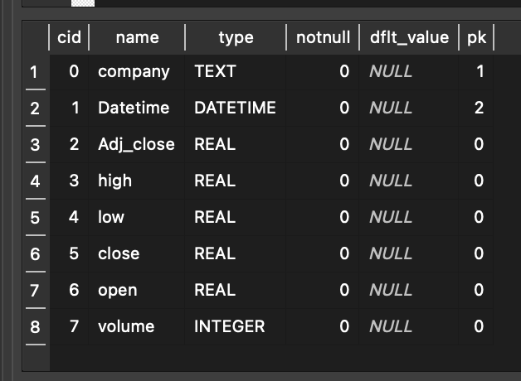

1. Find no. of records from “basic_stock_data” table where start date is less current date

sqlite3> SELECT COUNT (*) FROM basic_stock_data WHERE Datetime < date('now');

1. INSERT data into job table

sqlite3> INSERT INTO job ( job_id,

collection_strt_tm,

successful_fetch_tm,

job_status,

num_rec

) VALUES ('D00000003',

'2023-07-10 09:15:00',

'2023-07-10 17:40:00',

'done',

1864

);

1. Fetch all pending and failed jobs from the job table.

sqlite3> select * from job where job_status = 'pending' or job_status = 'failed';